

Project Report

Group No.

Project Title
E Commerce Website

Submitted By
Muhammad Subhan Naeem Qureshi
48802
Abdul Haseeb
46997

Teacher
Dr. Nadeem Ahsan

ABSTRACT:
In today’s fast-changing business environment, it’s extremely important to be able to respond to client needs in the most effective and timely manner. If your customers wish to see your business online and have instant access to your products or services. Online Shopping is a lifestyle e-commerce web application, which retails various fashion and lifestyle products (Currently Men’s Wear). This project allows viewing various products available enables registered users to purchase desired products by using Cash on Delivery (Pay Later) option. This project provides an easy access to Administrators and Managers to view orders placed using Pay Later. In order to develop an e-commerce website, a number of Technologies must be studied and understood. These include multi-tiered architecture, server and client side scripting techniques, implementation technologies such as html, CSS and JavaScript. This is a project with the objective to develop a basic website where a consumer is provided with a shopping cart application and also to know about the technologies used to develop such an application. This document will discuss each of the underlying technologies to create and implement an ecommerce website.

INTRODUCTION:
E-commerce is fast gaining ground as an accepted and used business paradigm. More and more business houses are implementing web sites providing functionality for performing commercial transactions over the web. It is reasonable to say that the process of shopping on the web is becoming commonplace. The objective of this project is to develop a general purpose e-commerce store where product like clothes can be bought from the comfort of home through the Internet. However, for implementation purposes, this paper will deal with an online shopping for clothes. An online store is a virtual store on the Internet where customers can browse the catalog and select products of interest. The selected items may be collected in a shopping cart. At checkout time, the items in the shopping cart will be presented as an order. At that time, more information will be needed to complete the transaction. Usually, the customer will be asked to fill or select a billing address, a shipping address, a shipping option, and payment information such as credit card number. An e-mail notification is sent to the customer as soon as the order is placed.

Description:
- Any member can register and view available products.
- Only registered member can purchase multiple products regardless of quantity.
- Contact Us page is available to contact Admin for queries.
- There are three roles available: Visitor, User and Admin.

- Visitor can view available products.
- User can view and purchase products.
- An Admin has some extra privilege including all privilege of visitor and user.

- Admin can add products, edit product information and add/remove product.
- Admin can add user, edit user information and can remove user.
- Admin can ship order to user based on order placed by sending confirmation mail.

Development / Research Methodology:
We use Waterfall development model for our project, our methodology is designed to help the customer make maximum use of our app through the digital process. The waterfall approach was the first SDLC Model to be used widely in Software Engineering. It incorporates all aspects related to our website and application that allow the customer to ensure the final product is of the highest standards.
Following are the steps involved;
Requirement:
We analyze our customer target market's requirements. Who will be visiting our e-commerce website? What will be the purpose of their visiting the application and website? How can our website cater best according to their needs, and what information can we share with them?
Analysis:
We analyze our online target audience as well as the offline target audience. We also assess our differentiation strategy to best attract and retain online visitors. Our e-commerce website will also undergo comprehensive search engine analysis twice during the project.
Development:
We look at the trends in the market to ensure that our digital process of buy products and planning of those will have the latest technology, components, and elements. We take time to think outside the box and consider more than students' present-day needs so that we can sustain any upcoming future needs.
Design:
We consider this stage to be one of the most crucial factors in any project. We justify every single aspect of the design to ensure that each element is serving a specific need. The website is truly designed to attract, retain and enhance the end-user experience.

Implementation:
The application development is in the process in which code would mainly consist of html, CSS and JavaScript. As the application and the website are in progress cannot define the entire development as there are going to be challenges and the scope is still undefined. The purpose is to provide an overview that the process of development of the Application.
Deployment:
The process is still in the build phase and we have started working on this. Initially, the team is working on the UI of the application and website as time goes on the development detail shall be provided in the documentation. As working on the UI of the website and application were using HTML, CSS, and JavaScript for the website and the process goes on for the Application.

USE CASE:

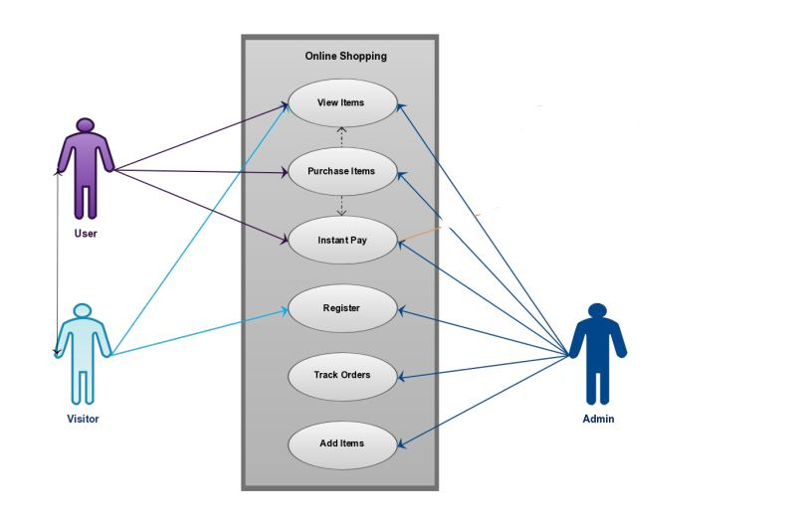

ENTITY RELATIONSHIP DIAGRAM:

FUNCTIONAL REQUIREMENTS:

- Speed
- Mobile-Friendliness
- Product Attributes
- Order & Checkout Flow
- Accessibility

NON FUNCTIONAL REQUIREMENTS:

- Usability
- Security
- Performance

BUG TRACKING:
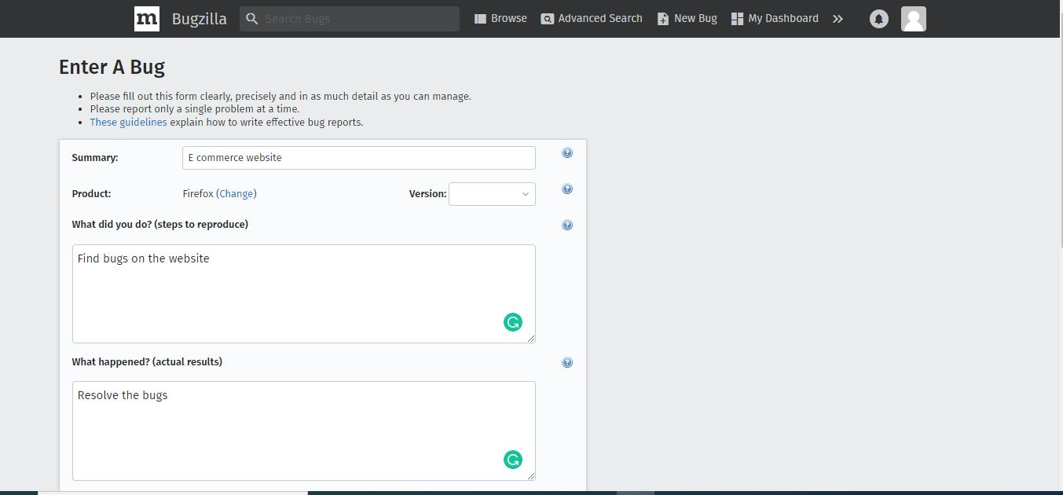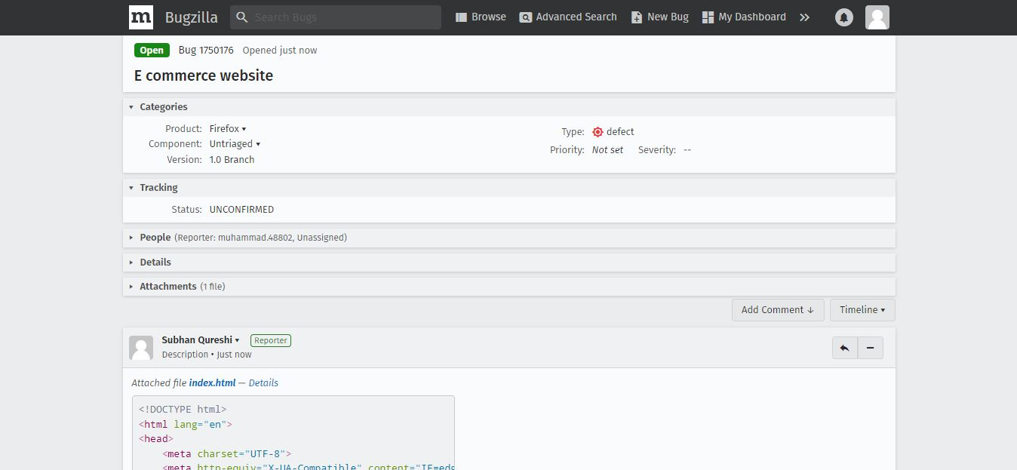

SCREENSHOTS:

